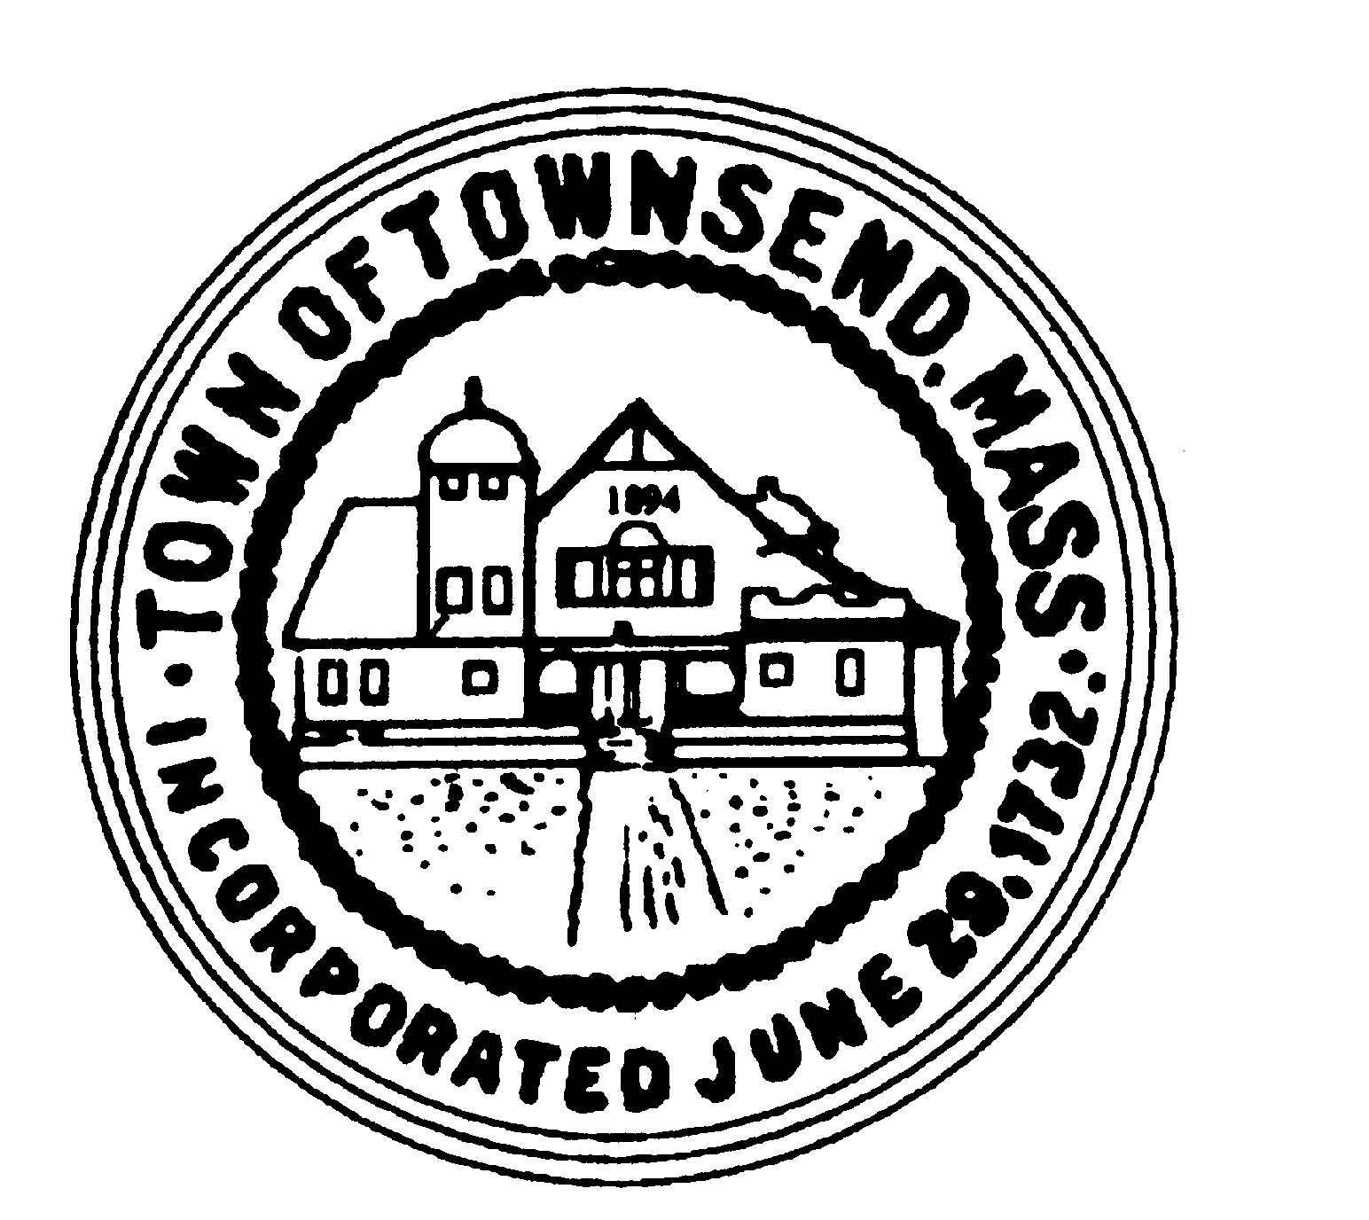
TOWNSEND BOARD OF HEALTH
272 Main Street
Townsend, Massachusetts 01469

Christopher Nocella, Chairman James Le’Cuyer, Vice-Chairman Gavin Byars, Clerk
Office (978) 597-1713 Fax (978) 597-8135
WEDNESDAY, August 10, 2022, at 600pm, EST
Board of Health members and staff will meet in the
Meeting Room 2 Memorial Hall 272 Main Street

This meeting of the Board of Health will be held in-person at the location provided on this notice. Members of the public are welcome to attend this in-person meeting.

PRELIMINARIES
  - Roll Call
  - Additions or Deletions not anticipated 48 hours in advance
    - MOVE 1.6 TO FUTURE AGENDA
    - DELETE 1.7 NO OTHER PERMITS FOR REVIEW

APPOINTMENT/HEARINGS
  - 22 Main Street – Change of use update
  - 5 Turnpike Road – Housing update
  - 513 Main Street – Release of Restrictive Covenant
  - Septic Regulations Update
  - Other Septic and approvals needed
  - CO-VID Update
  - Monkeypox Update
WORK SESSION
  - Invoices
  - Minutes of June 2022
  - Recycling Center Update
    - Acceptance of Mattress Grant
  - Future Agenda Items
    - Stable Regulations Update – Tabled TBD
    - Next Meeting: August 24th, 2022, 6PM
ADJOURNMENT

Board of Health Meeting Minutes August 10, 2022

- Roll Call: All present meeting called to order at 6pm.

- 1.6 moved to future agenda, delete 1.7

- 22 Main Street Change of Use Update: Certificate of Compliance has been issued but the Planning Board site plan has parking in the septic and leach field. Rick provided comments to the Planning Board.

- 5 Turnpike Road Housing Update: 2 weeks ago, verification of events were verified for court filing. Elder services is still hoping to clean the apartment with the help of the owner. State has paid back rent but still in violation of lease with sanitation violations. Hoping to move up eviction process with this information.

- 513 Main Street Release of Restrictive Covenant: 1976 original system addition warranted two-bedroom deed restriction. 6/9/22 COC was issued for new system for four (4) bedrooms. Lawyer has written up documentation for removal on the deed. A MOTION was made by GB and 2nd by JL to have the Board will sign two (2) copies in front of a constable. Voting 3/0 MOTION carries.

- COVID Update: Last report 8/4 19 cases confirmed through testing. 14-day average is 14.9 cases per 1,000 population 19.9 for State and county. Vaccination rates are not changing much. 0-4 age group recently opened up eligible for vaccinations. Chairman Nocella requested another clinic when the new vaccinations come out. Word is September. Nashoba will not be a provider for that shot. The Board agreed to monthly postings on the website vs. weekly.

- Monkeypox Update: 1 case in Nashoba district. Website under useful links will have this added

- Invoices were signed as approved.

- Minutes of June were continued.

- Recycling Center Update: Irene Congdon appeared before the Board to explain 96 communities are currently taking recyclable mattresses through a grant provided by the MassDEP to purchase a container at Recycling Center in the amount of $10,000 for the container only. This grant will not support transporting and disposal of the mattresses as in the previous years. She is not aware of the costs for the disposal at this time. Chairman Nocella is concerned about fines that will be incurred to the town if the mattresses are denied as recyclable or stacking improperly. Sean Pearson joined the meeting at 640pm. Irene explained to Sean that if the mattresses are not recyclable, they are trash, and you will charge them for it. The Board is still very confused where they would put trash as they are not allowed to accept trash at the Center. Irene states in the bulky container that you already put them in, and nothing is changing. The Board continues the discussion until staff can contact vendors and get more information.

- Next meeting August 24th at 6pm.

- A MOTION was made by JL and 2nd by GB to adjourn the meeting. Voting 3/0 MOTION carries. Meeting adjourned at 7:10pm

