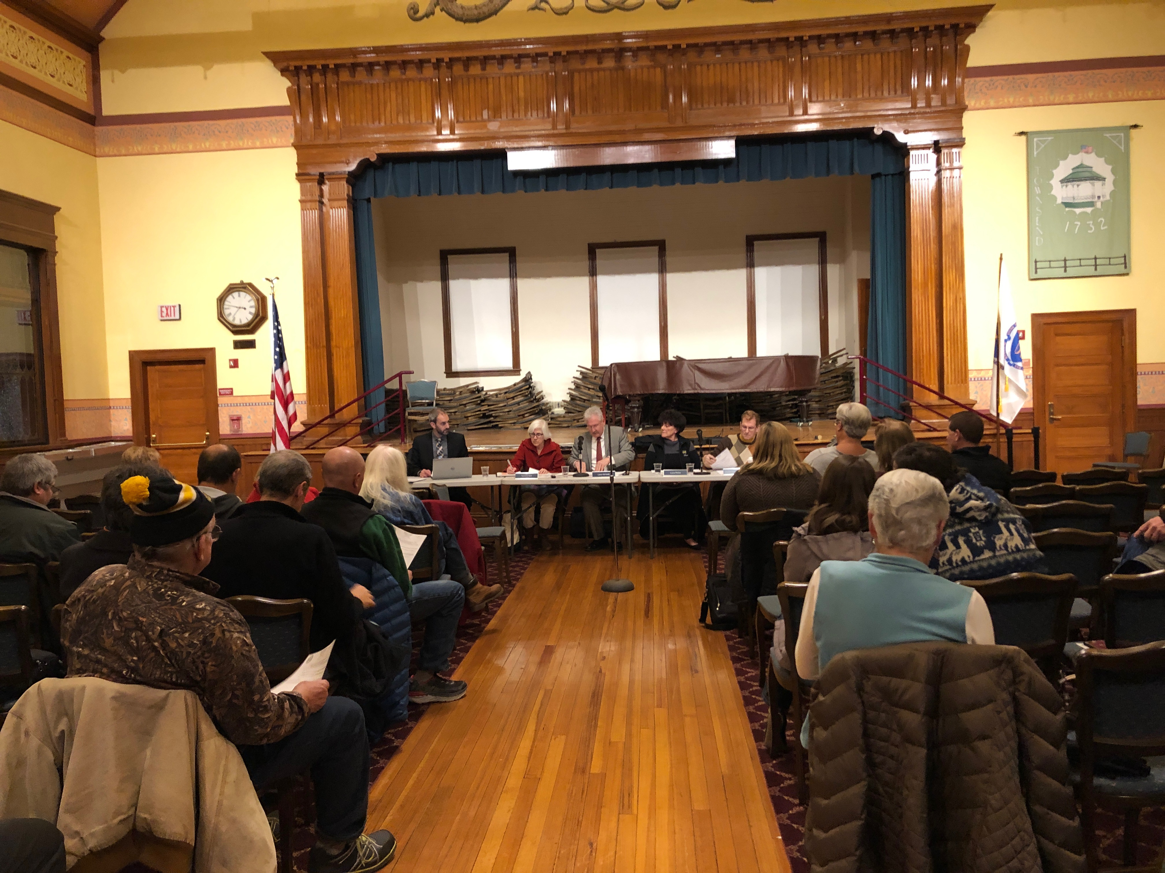

***Townsend Planning Board Annual Report 2018***

***Chairman: Lance McNally***

***Vice Chair: Laura Shifrin***

***Clerk: Veronica Kell***

***General Member: Jerrilyn Bozicas***

***General Member: Charles Sexton-Diranian***

The Planning Board’s responsibilities include the review and approval of Subdivisions and Site Plan projects requiring Special Permits; Approval Not Required (ANR) Plans for subdividing lots, and applications submitted under the Scenic Roads Act.  The Board holds public hearings for new zoning bylaw proposals and/or zoning bylaw amendments and submits recommendations to Town Meeting relative to these proposals, serves as the Stormwater Authority to oversee the Stormwater Management Bylaw, and is in charge of updating the Town’s Master Plan.  Agendas are posted on the bulletin board outside Memorial Hall, 272 Main Street, Townsend, MA and on the Townsend Town website ([www.townsend.ma.us](http://www.townsend.ma.us/)).  Meetings are open to the public.

Among the arrivals and departures of Board members this year, none was felt more than the loss of Kathleen Araujo. The Planning Board are grateful for the opportunity to have had the guidance of the Town’s past Land Use Coordinator, Kathleen (Kathy) C. Araujo as a member of our board. Kathy passed away on April 3, 2018. We feel very blessed that we were able to beneﬁt from her vast knowledge in the areas of state law in regards to all application processes brought before the board. Kathy chaired our ﬁrst ever Solar by Law Committee which produced the bylaw that the Town approved. Kathy is sorely missed.

The Board saw departures from two other members; Edward Howard, II and, Christopher Nocella.  The board thanks them for their invaluable volunteer service and contributions to the work of the Board.  Veronica Kell was elected to the Board, Jerrilyn Bozicas and Charles Sexton-Diranian were appointed to full members of the Board joining Lance McNally (Chair) and Laura Shifrin (Vice-Chair).   The Board welcomed Elizabeth Faxon to the team as Planning and Zoning Administrator in February 2018.

The Planning Board supports a dedicated group of Master Plan Committee members who are progressing through the long-anticipated update of the Master Plan.  The Master Plan Committee enlisted the expertise of the Montachusett Regional Planning Commission (MRPC) to facilitate five community input meetings to gather perspectives and visions from the people of Townsend.   The Committee currently is writing chapters of the Master Plan Update, and anticipates deployment of a town-wide survey in March 2019.  A final draft of the Master Plan Update document is anticipated to be availableby June 2019.

In addition to the Master Plan Committee, the Planning Board assisted other Town departments via responding to requests from the Board of Selectmen to comment on Chapter 61 land transitions andcommittee appointments, and informulating a strategy for local regulation of Adult Use Recreational Marijuana.  The Planning Board worked closely with Town Counsel, the Building Department, Zoning Board of Appeals, Board of Health, Highway Department, Conservation Commission, Historical Commission, Board of Assessors, Townsend Housing Authority, Town Clerk, and public safety officials to gather perspective and comment on applications under review and gather input to develop and amend bylaws.

This past year the Planning Board heard four Site Plan Review/Special Permits withtwo associated site walks, 6 ANR plans to subdivide lots and one Stormwater Permit.  The Board held a public hearing on a proposed amendment to the Accessory Apartment in a Residential District bylaw and two public hearings to gather input and guidance from the residents on their perspective of local regulation of Adult Use Recreational Marijuana.

The Planning Board recommended appointment of two representatives to serve on town committees; Kelly Kelly to the Charter Review Committee and, Natalie Call to the Capital Planning Committee.

In addition to their responsibilities as members of the Planning Board, Laura Shifrin served on the Montachusett Regional Planning Commission and Town Properties Committee and as Planning Board representative.  Veronica Kell served on the Master Plan Committee as an ex-officio member.

**Adult Use Recreational Marijuana regulatory process**

At all Board meetings, and through many behind the scene efforts, The Board worked diligently with citizens, town staff, town counsel, other towns and the State using best practices in a process of proposing a framework for regulating Recreational marijuana establishments in the Town. The Board recommended two warrant articles at the Special Town Meeting December 20, 2019. Mr. Charles Sexton-Diranian represented the Planning Board on Special Town Meeting floor to move the following Articles**:**

STM Warrant Article #29 - §145-89 Temporary Moratorium on Recreational Marijuana Establishments – request for extension through June 29, 2019.

STM Warrant Article #30 - §145-90 Recreational Marijuana Establishment Zoning Proposal.

The voters passed both Warrant articles and awaits final approval from the Attorney General. The Board continues to work through the Adult Use regulatory process utilizing staff, resources and perspective of the citizens of Townsend.

**Accessory Apartment in a residential District proposed amendment process**

The Board worked with other town departments throughout the year to formulate amendments to the Accessory Apartment bylaw and optimize the permitting process. Work continues with discussions amongst the Planning Board, Townsend Housing Authority, Zoning Board of Appeals the public bodies within which work together formally in the permitting process. The amended bylaw proposal is anticipated to be before the Town at the 2019 Annual Town meeting.

Respectfully submitted,

Lance McNally

Chairman